**Experiment No. : 03**

**Aim** : Write a program to implement Depth-First Search.

**Theory** : Depth-First Search (DFS) is an Algorithm for traversing or searching tree or graph

data structure. One starts at the root (selecting some arbritrary node in the case of graph),

and explore as far as possible along each branch before backtracking.

**Algorithm** :

1. Start by putting any one of the graph vertices on top of a stack.
2. Take the top item of a stack and it to the visited list.
3. Create a list of that vertex’s adjacent. Add the one which aren’t in the visited list to the top of the stack.
4. Keep repeating steps 2 and 3 until the stack is empty.

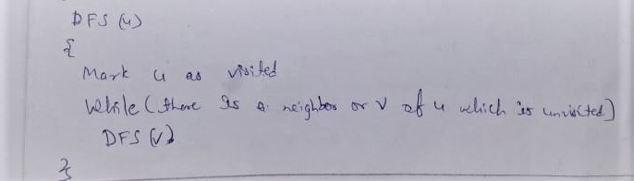

**Example :**

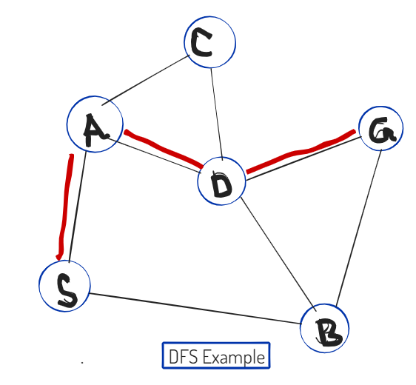

**Implementation:**

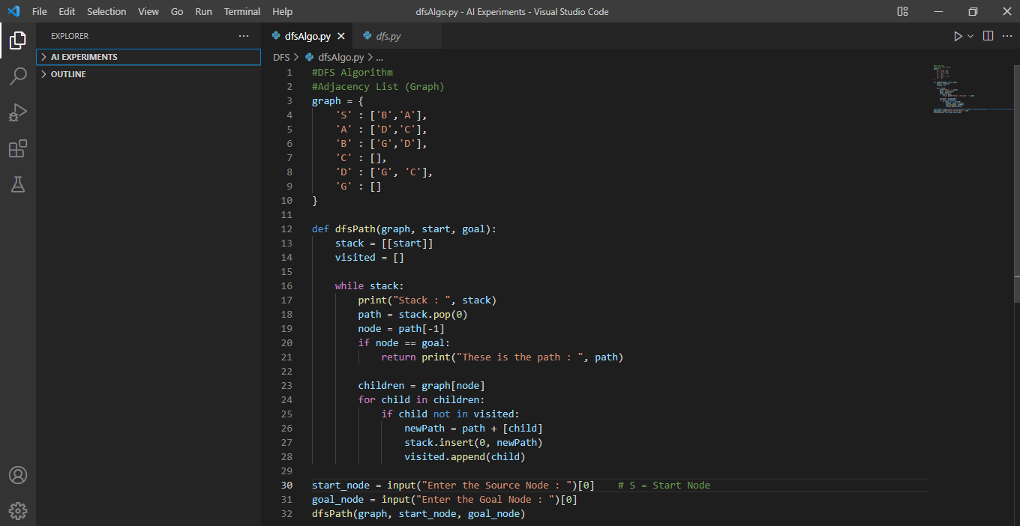

**Output :**

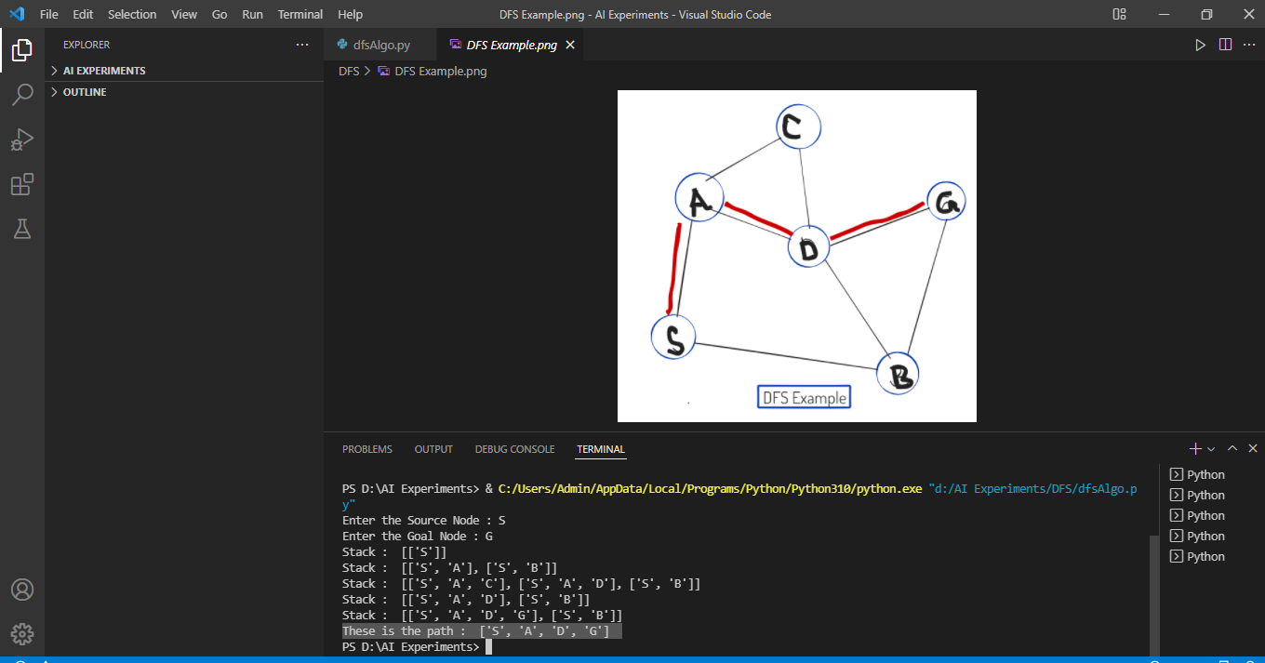

**Conclusion :**  I learned how to implement Depth-First Search Algorithm.